Preview of table salary contracts before normalization:

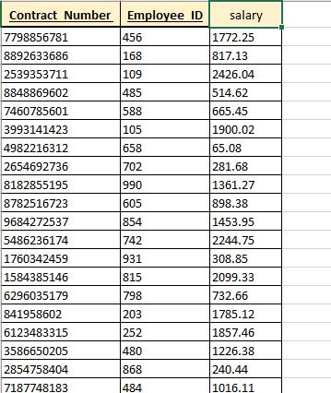

Entity is in 3NF. It doesn’t need to be normalized.

PK is composite contract_number and employee_ID.

Preview of table after normalization

